**SMS Spam Detection**

#library and packages

import numpy as np

import pandas as pd

#import dataset

dataset=pd.read_csv("SMSSpamCollection",sep='\t',names=['labels','message'])

dataset

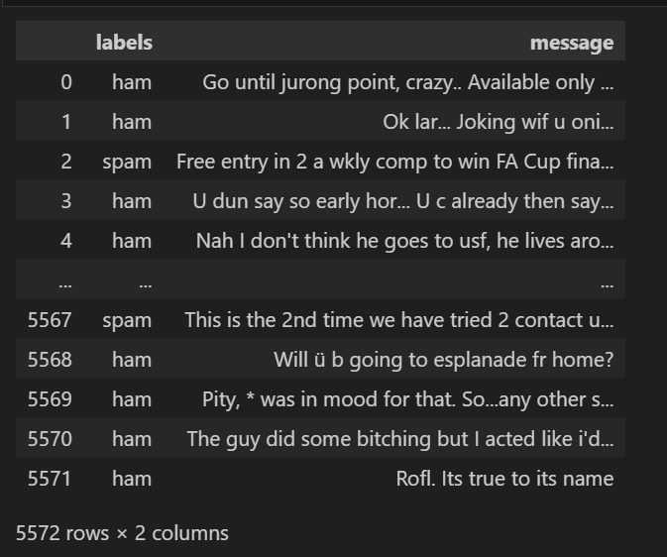

dataset.info()

dataset.describe() #to get count of labels

dataset['labels'] = dataset['labels'].map({'ham': 0, 'spam': 1}) # mapping with 0 and 1

dataset

#visulation

import matplotlib.pyplot as plt

import seaborn as sns

%matplotlib inline

# count plot for spam vs ham to check imbalance

plt.figure(figsize=(8,8))

g = sns.countplot(x="labels", data=dataset)

plt.title('Countplot for spam vs ham')

plt.xlabel('Is the SMS spam')

plt.ylabel('Count')

#so we can see the data is imbalance

#handling imbalance dataset with oversampling

only_spam=dataset[dataset["labels"]==1]

only_spam

len(dataset)-len(only_spam)

#so we need to replicate spam 6-7 times to make dataset imbaalnce

count=int((dataset.shape[0]-only_spam.shape[0])/only_spam.shape[0])

count



for i in range(0,count-1):

    dataset=pd.concat([dataset,only_spam])

dataset.shape



# count plot for spam vs ham to check imbalance

plt.figure(figsize=(8,8))

g = sns.countplot(x="labels", data=dataset)

plt.title('Countplot for spam vs ham')

plt.xlabel('Is the SMS spam')

plt.ylabel('Count')

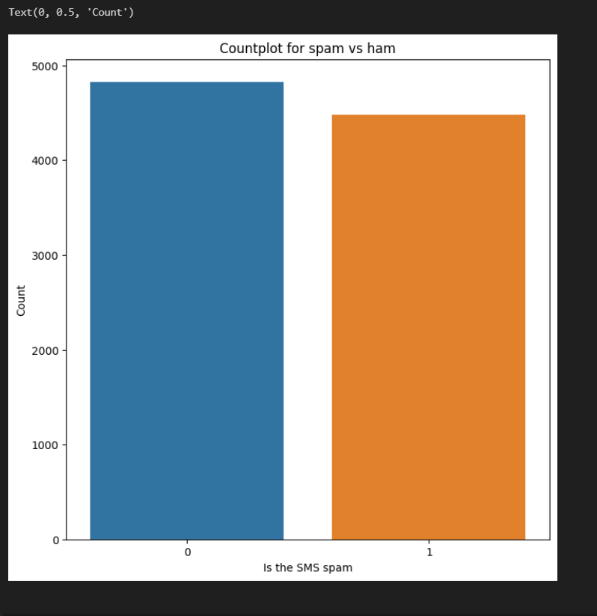

# creating new features

dataset['word_count']=dataset['message'].apply(lambda x: len(x.split()))

dataset

plt.figure(figsize=(12,6))

#(1,1)

plt.subplot(1,2,1)

g=sns.histplot(dataset[dataset["labels"]==0].word_count,kde=True)

p=plt.title('Distribution of word count for ham msgs')

#(1,2)

plt.subplot(1,2,2)

g=sns.histplot(dataset[dataset["labels"]==1].word_count,color="red",kde=True)

p=plt.title('Distribution of word count for spam msgs')

plt.tight_layout() ## padding in between

plt.show()

#createing new feature of containing_currency_symbol

def currency_present(data):

    currency_symbols=['¢','$','€','£','₹']

    for i in currency_symbols:

        if i in data:

            return 1

    return 0

dataset["contains_currency_symbols"]=dataset["message"].apply(currency_present)

dataset

#countplot for contains_currency_symbol

plt.figure(figsize=(8,8))

g=sns.countplot(x='contains_currency_symbols',data=dataset,hue="labels")

p=plt.title('Countplot for containing currency symbols')

p=plt.xlabel('does SMS contains currency_symbol')

p=plt.ylabel('count')

p=plt.legend(labels=["Ham","Spam"],loc=9)

#creating new feature of containing number

#ord function to convert into ascii and then again to normal

def number(data):

    for i in data:

        if ord(i) >= 48 and ord(i) <= 57:

            return 1

    return 0

dataset["contains_number"]=dataset['message'].apply(number)

dataset

#countplot for how many msgs have numbers

plt.figure(figsize=(8,8))

g=sns.countplot(x='contains_number',data=dataset,hue="labels")

p=plt.title('Countplot for containing numbers')

p=plt.xlabel('does SMS contains numbers')

p=plt.ylabel('count')

p=plt.legend(labels=["Ham","Spam"],loc=9)

#data cleaning because unstructured data

import nltk

import re

nltk.download('stopwords')

nltk.download('wordnet')

from nltk.corpus import stopwords

from nltk.stem import WordNetLemmatizer

corpus = []

wnl = WordNetLemmatizer()

for sms in list(dataset.message):

    message = re.sub(pattern='[^a-zA-Z]', repl=' ', string=sms)  # filtering out special characters and numbers

    message = message.lower()

    words = message.split()  # tokenizing (added parentheses after split)

    filtered_words = [word for word in words if word not in set(stopwords.words('english'))]

    lemm_words = [wnl.lemmatize(word) for word in filtered_words]

    message = ' '.join(lemm_words)

    corpus.append(message)

corpus

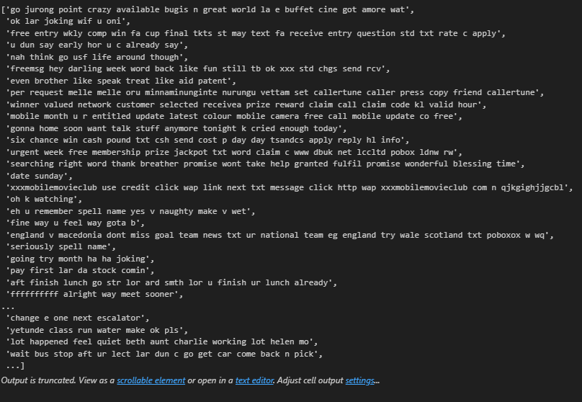

#creating the bag of words model

from sklearn.feature_extraction.text import TfidfVectorizer

tfidf = TfidfVectorizer(max_features=500)

vectors = tfidf.fit_transform(corpus).toarray()

feature_names = tfidf.get_feature_names()

#seprating dependent and independent

x=pd.DataFrame(vectors,columns=feature_names)

y=dataset['labels']

#cross validation report

#creating cnfusion matrix

from sklearn.model_selection import cross_val_score,train_test_split

from sklearn.metrics import classification_report,confusion_matrix

x_train, x_test, y_train, y_test = train_test_split(x, y, test_size=0.2, random_state=42)

x_test

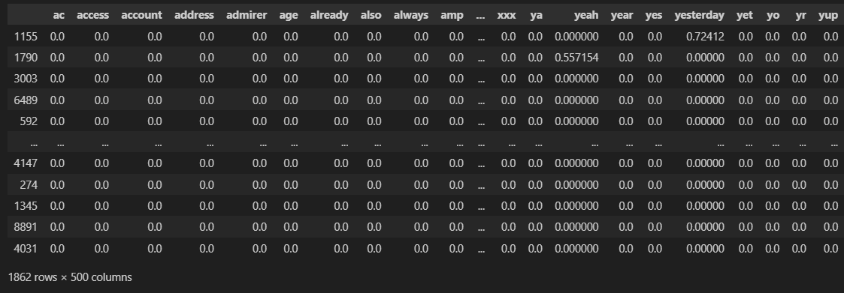

#trining using naive bayes

from sklearn.naive_bayes import MultinomialNB

mnb=MultinomialNB()

cv=cross_val_score(mnb,x,y,scoring= 'f1',cv=10)

print(round(cv.mean(),3))

print(round(cv.std(),3))



mnb.fit(x_train,y_train)

y_pred=mnb.predict(x_test)

print(classification_report(y_test,y_pred))

cm = confusion_matrix(y_test, y_pred)

plt.figure(figsize=(8, 8))

axis_labels = ['ham', 'spam']

g = sns.heatmap(data=cm, xticklabels=axis_labels, yticklabels=axis_labels, annot=True, fmt='g', cbar_kws={"shrink": 0.5})

plt.title("Confusion Matrix of our Multinomial Naive Bayes Model")

plt.xlabel('Actual Values')

plt.ylabel('Predicted Values')

plt.show()

#using decision tree

from sklearn.tree import DecisionTreeClassifier

dt=DecisionTreeClassifier()

cv1=cross_val_score(dt,x,y,scoring='f1',cv=10)

print(round(cv1.mean(),3))

print(round(cv1.std(),3))



dt.fit(x_train,y_train)

y_pred1=dt.predict(x_test)

print(classification_report(y_test,y_pred1))

cm = confusion_matrix(y_test, y_pred1)

cm



plt.figure(figsize=(8, 8))

axis_labels = ['ham', 'spam']

g = sns.heatmap(data=cm, xticklabels=axis_labels, yticklabels=axis_labels, annot=True, fmt='g', cbar_kws={"shrink": 0.5})

plt.title("Confusion Matrix of our Multinomial Naive Bayes Model")

plt.xlabel('Actual Values')

plt.ylabel('Predicted Values')

plt.show()

def predict_spam(sms):

    message = re.sub(pattern='[^a-zA-Z]', repl=' ', string=sms)  # filtering out special characters and numbers

    message = message.lower()

    words = message.split()  # tokenizing (added parentheses after split)

    filtered_words = [word for word in words if word not in set(stopwords.words('english'))]

    lemm_words = [wnl.lemmatize(word) for word in filtered_words]

    message = ' '.join(lemm_words)

    temp=tfidf.transform([message]).toarray()

    return dt.predict(temp)

#prediction 1

sample_message=""

if predict_spam(sample_message):

    print('this is a spam message')

else:

    print('this is not a spam message')